# 單元名稱(LAB I2605)

Name : **劉泰佑**

Student ID : C100E030

## Objective

To be able to control LED color from our website through ThingSpeak by using its API.

## Working theory

ESP8266 is a MCU which is mainly used in IoT appliances as the main board or the brain of the system. ESP8266 is equipped with wifi module which can be used to send data through the internet once the board is connected to the internet. In this case we tried to use ESP8266 to control each LED color where one LED has 4 pins, ground, red pin, green pin, and blue pin that are connected to the ESP8266. We use ThingSpeak as a bridge where we can control the LED color from the website. Where in the website there are 4 buttons the red button, green button, blue button, and turn off button, all of them button are use to change the color of the LED. So by using ThingSpeak we put the write API code in our website so that we can send data to the ESP8266 through the ThingSpeak, also we put our write API, read API, and channel id in the ESP8266 program files so that we can control and monitor the ESP8266 status.

## Experimental device and components)

* ESP8266,
* DHT22 Sensor,
* Thonny IDE,
* ThingSpeak,
* Access Point.

## Procedure

Open ThinkSpeak.com.



Fig. ‑

Create new account.

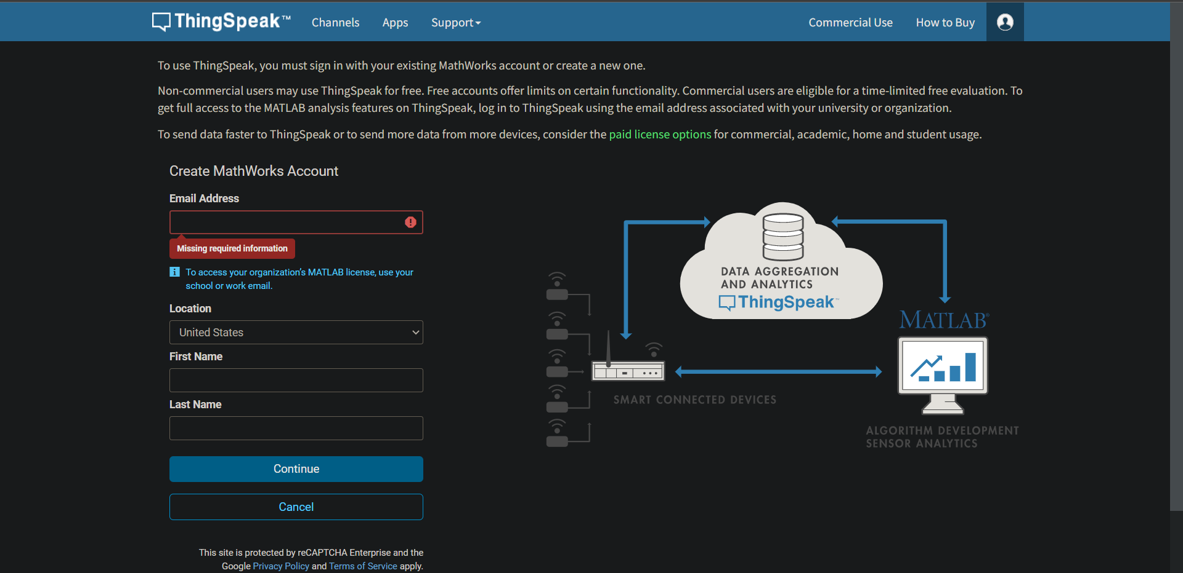

Fig. ‑2

Verify your account from your email inbox.

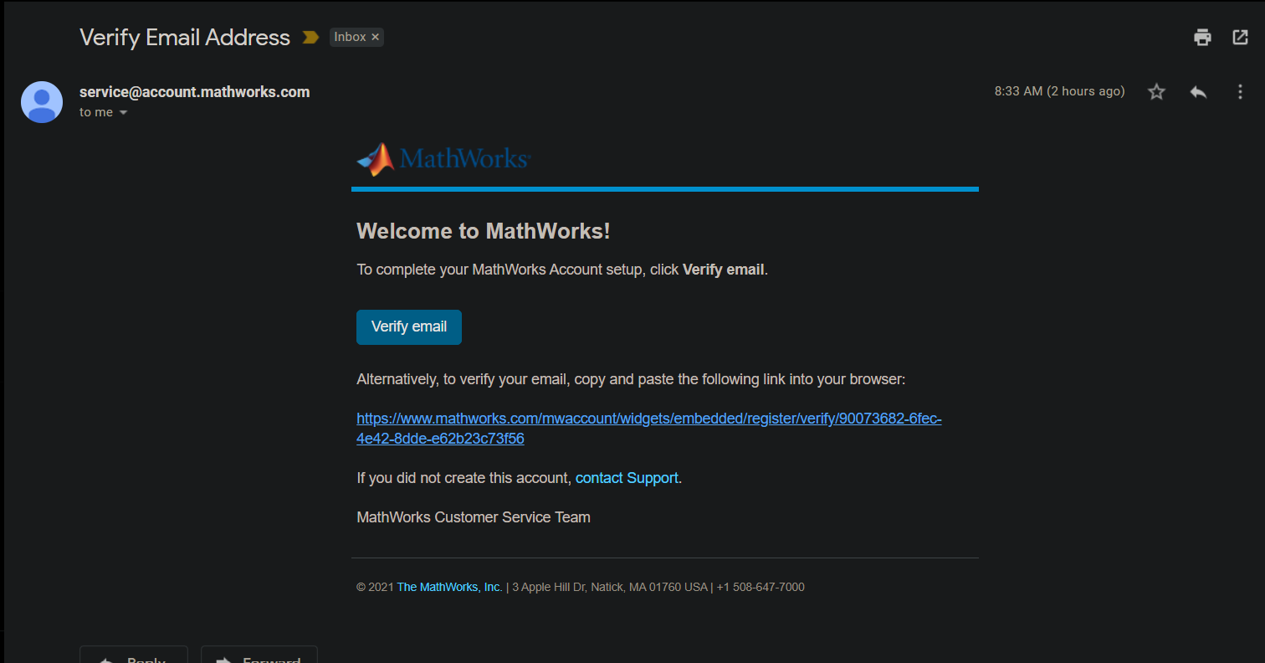

Fig. ‑3

Create new channel. We use 4 field here, the first field we use to manage all the command to the ESP8266 from the website. And the last three field are for the red, green, and blue LED status which is send my the ESP8266. We add the last three field so that we can monitor our LED status through ThingSpeak so that we can integrate it to our website.

Fig. ‑4

Copy both your API keys and your channel ID to your program.

Fig. ‑5

Create a website to control and monitor the LED colors, in this case we use HTML language to make the website and use Visual Studio Code IDE to create and edit the website.

Fig. 1.4‑6

After some editing in Visual Studio Code IDE our website should look like this.

Fig. 1.4‑7

Then what do next is to implemented code and API to our ESP8266 code.

Fig. 1.4‑8

## Results

After making sure everything are correct, then we just try it in real time. First open up your web control and assembly and run your ESP8266

Fig. 1.5-1.1

Fig. 1.5-1.2

Then we try to turn on the red LED using the button and we match the LED status on our web and real time. Also we can see the command input in the graph.

Fig. 1.5-2.1 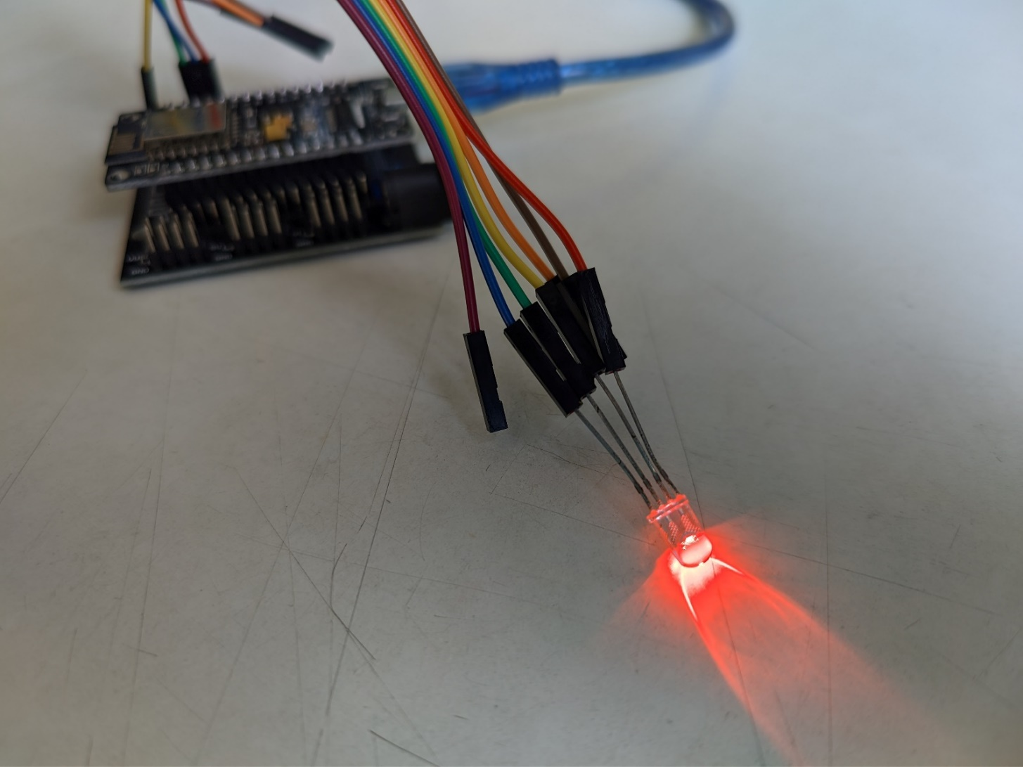

Fig. 1.5-2.2

Then we try to turn on green LED

Fig. 1.5-3.1A picture containing light

Description automatically generated

Fig. 1.5-3.2

Next we try to turn on the blue LED

Fig. 1.5-4.1 A picture containing striped

Description automatically generated

Fig. 1.5-4.2

Fig. 1.5-5.1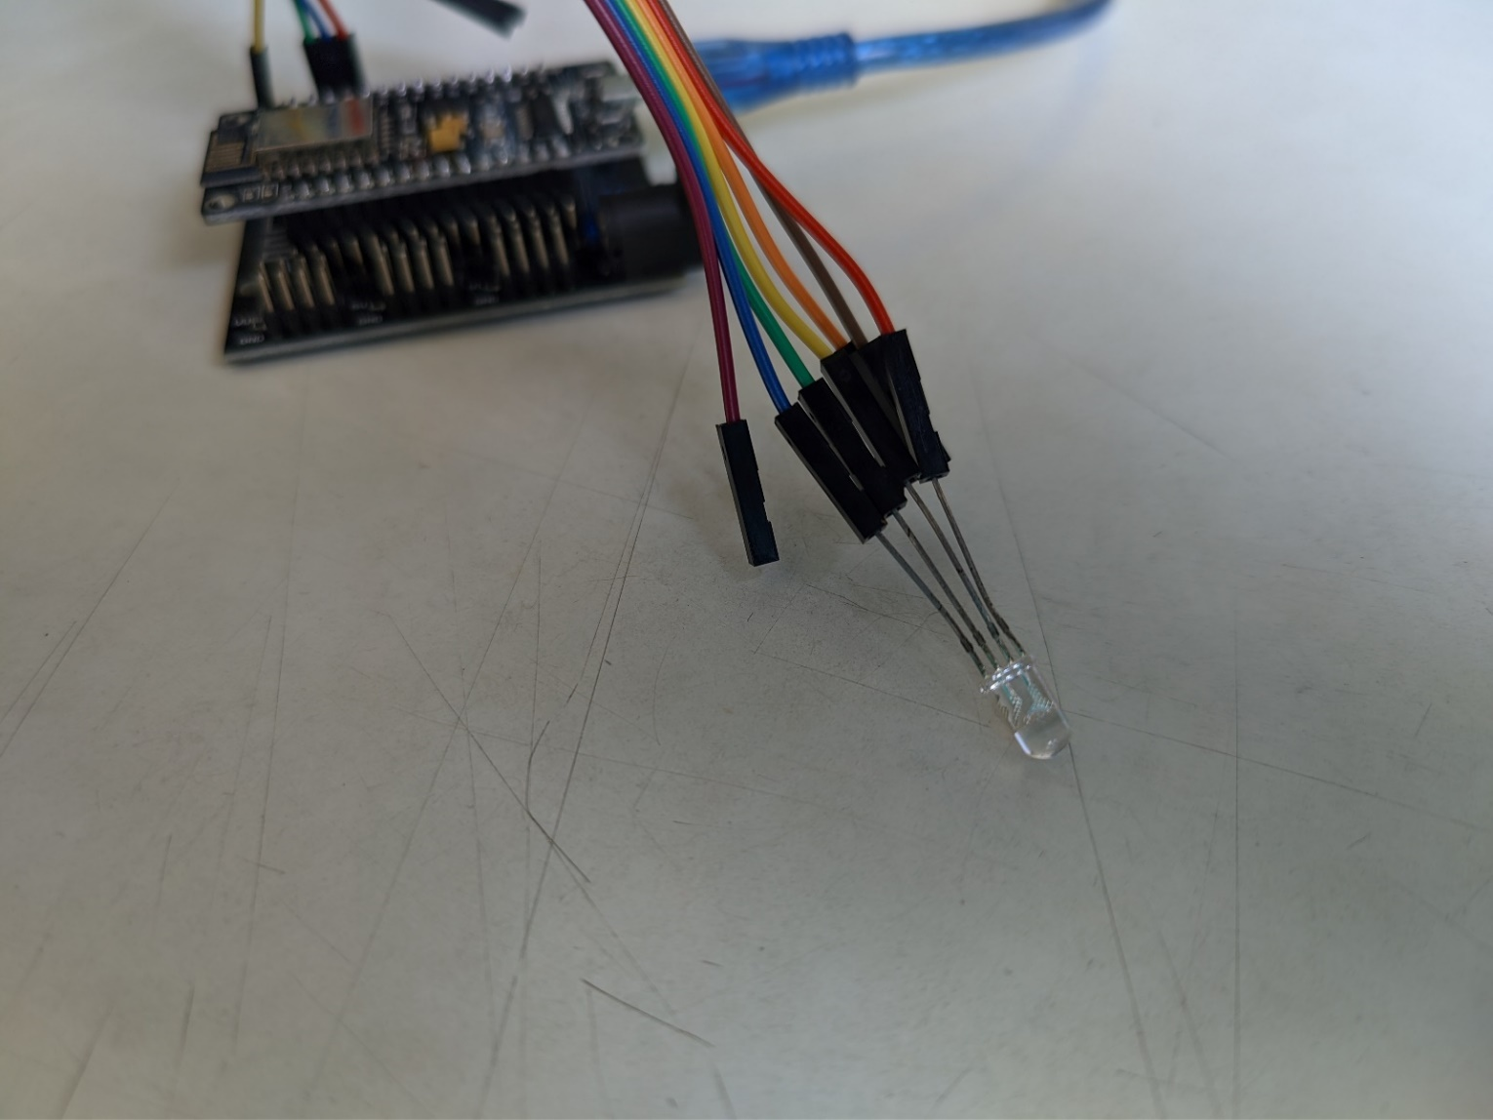

Fig. 1.5-5.2

## Conclusion and Discussion

In conclusion, setting up web controlled LED using ESP8266 is pretty simple, in the process we find some error but we manage to fix it. All you have to do is to make the website to control the LED, ESP8266 with RGB LED attach to it, ThingSpeak, and internet access. We have to insert our read and write API and our channel ID into the ESP8266 program, and also we insert write API to our website. And we should be able to successfully control aur LED through website.